**Python PROJECT REPORT**

(Project Semester: January-April 2025)

**Title of the Project: UK Train Rides Analysis and Visualization**

**Submitted by:**

**Omkar Subhankar  
Registration No.: 12312133  
Programme and Section: B.Tech CSE (K23FD)  
Course Code: INT375**

**Under the Guidance of:  
Baljinder Kaur (UID : 27952)**

**Discipline of CSE/IT**  
**Lovely School of Computer Science & Engineering**  
**Lovely Professional University, Phagwara**

**DECLARATION**

I, **Omkar Subhankar**, student of **Bachelors of Technology (B.Tech)** under CSE/IT Discipline at Lovely Professional University, Punjab, hereby declare that all the information furnished in this project report is based on my own intensive work and is genuine.

Date: 12-April-2025  
Registration No.: 12312133  
Name of the Student: **Omkar Subhankar**

# ****CERTIFICATE****

This is to certify that **Omkar Subhankar** bearing Registration No. **12312133** has completed **INT375** project titled **“UK Train Rides Analysis & Visualization”** under my guidance and supervision. To the best of my knowledge, the present work is the result of his original development, effort, and study.

**Baljinder Kaur**  
**School of Computer Science & Engineering**

**Lovely Professional University**  
**Phagwara, Punjab**

Date: **12-April-2025**

**ACKNOWLEDGMENT**

I would like to express my sincere gratitude to **Baljinder Kaur ma’am**, my project guide, for their invaluable support, guidance, and encouragement throughout the development of this project. Their expert insights and constructive feedback have been instrumental in shaping the project's outcome.

I am also thankful to **Lovely Professional University** for providing a conducive learning environment and access to resources that made this project possible. Additionally, I extend my appreciation to my professors and peers for their continuous motivation and insightful discussions, which greatly enhanced my understanding of the subject.

Lastly, I would like to acknowledge the unwavering support of my family and friends, whose encouragement has been a source of inspiration throughout this journey.

**Dataset Link**

<https://app.mavenanalytics.io/datasets>

**Charts and Visualization**

1.

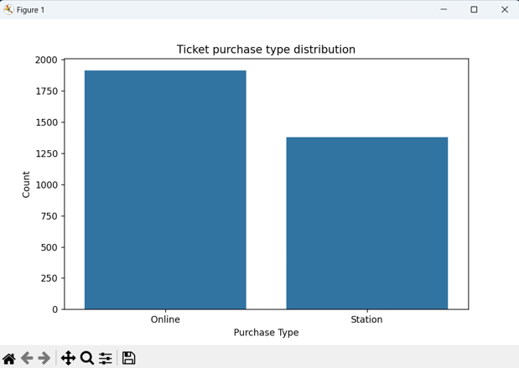

2.

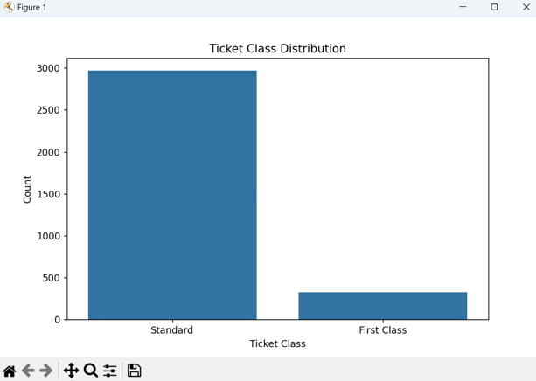

3.

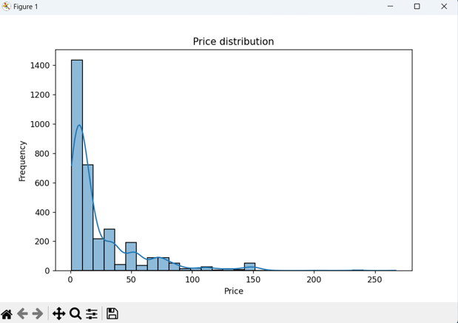

4.

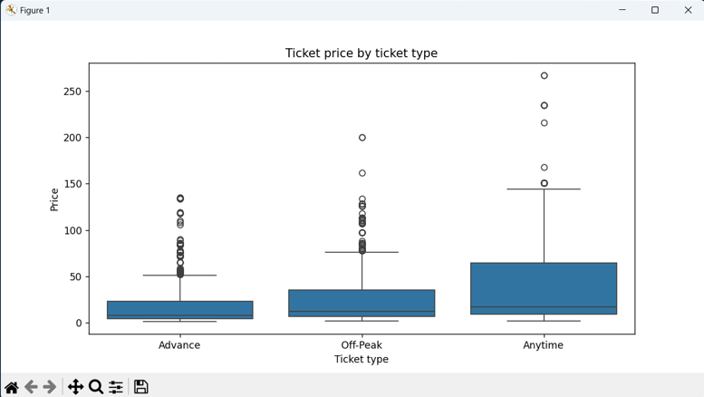

5.

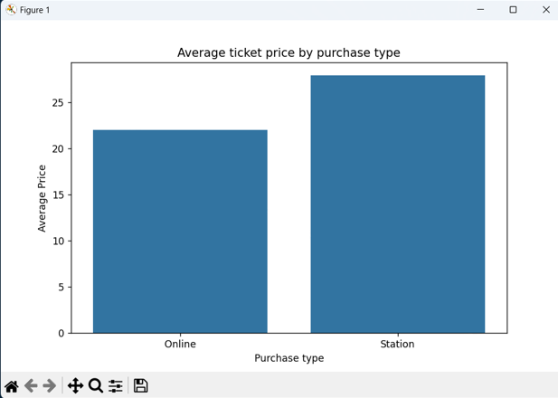

6.

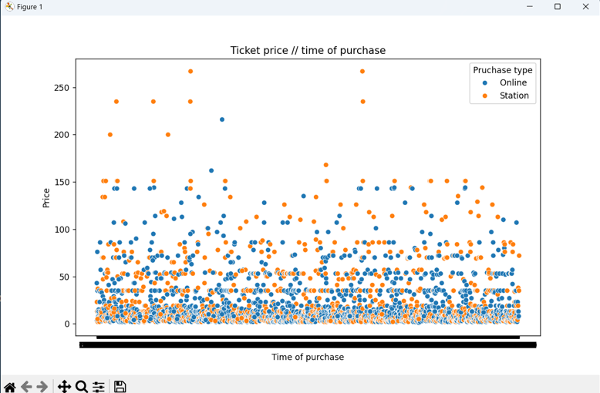

7.

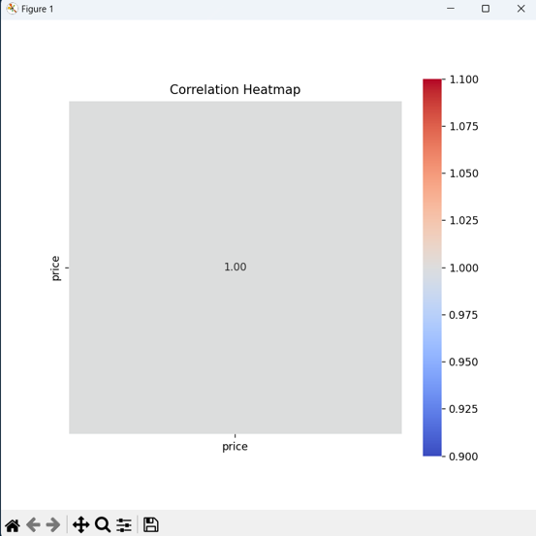

8.

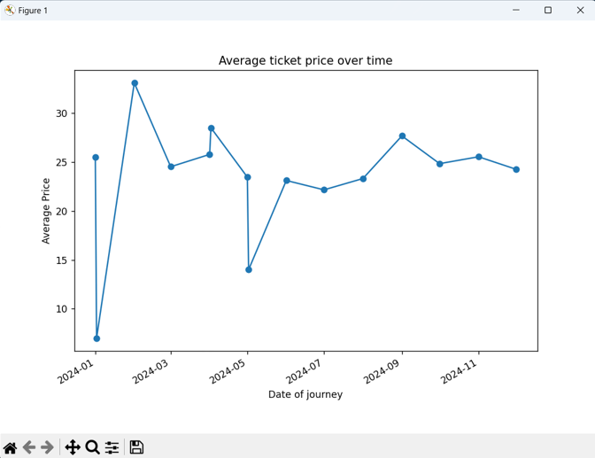

Python Code for Dataset Analysis

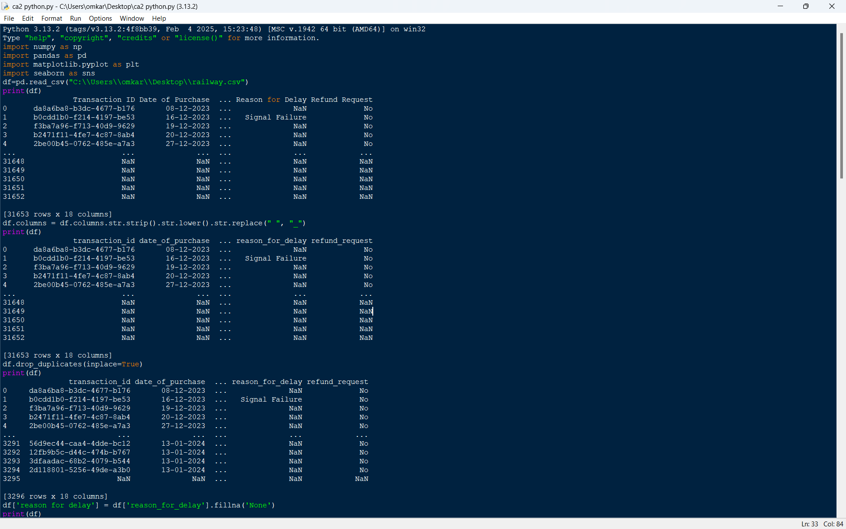

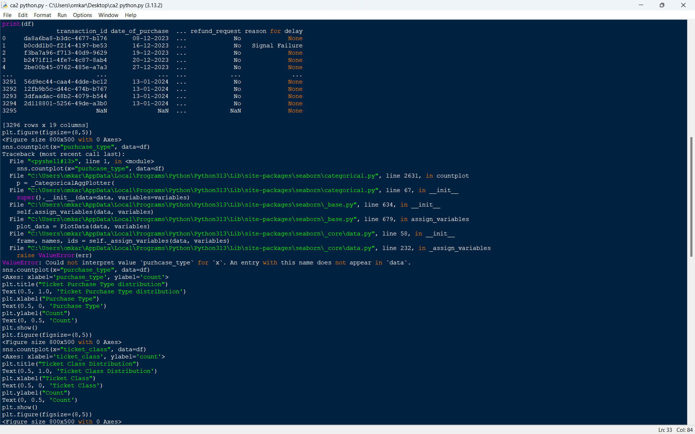

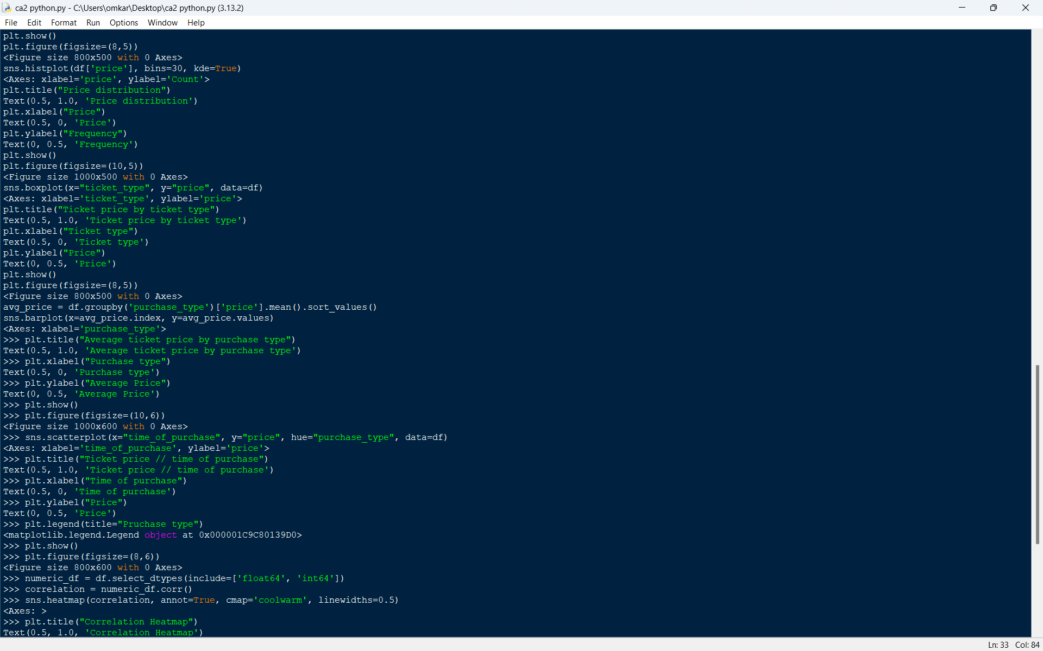

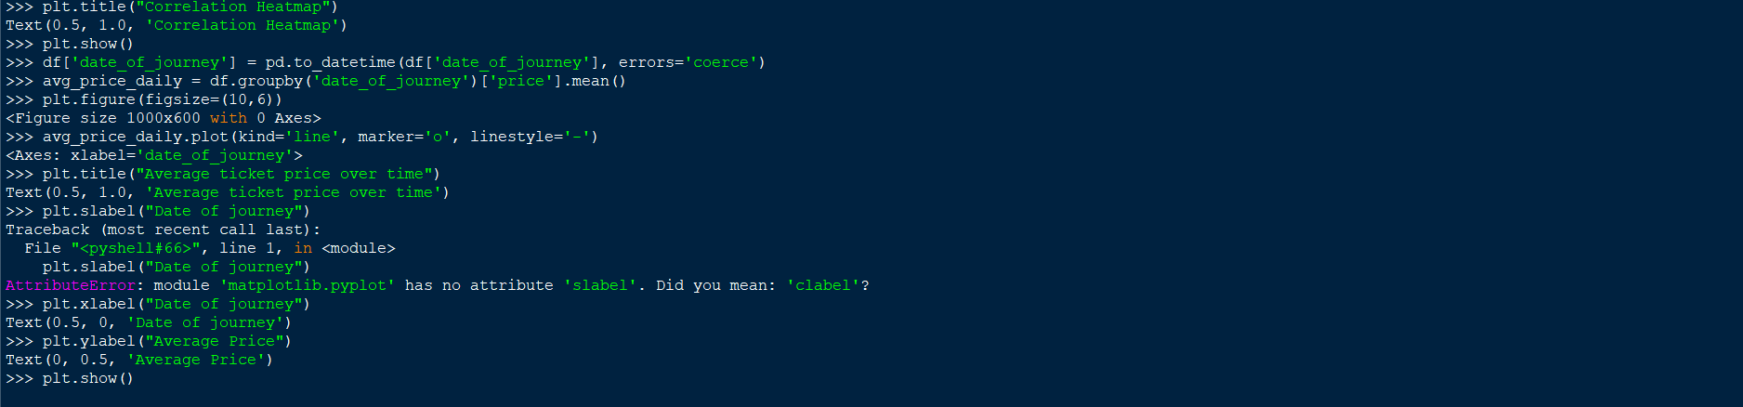

**LinkedIn:**

Link: [ <https://www.linkedin.com/posts/omkar2629_datascience-python-datavisualization-activity-7316413605866872832-Ie8B?utm_source=share&utm_medium=member_desktop&rcm=ACoAAENd0VsBy59LcKsqZ31idzmiz2ZW4BwJnvY> ]

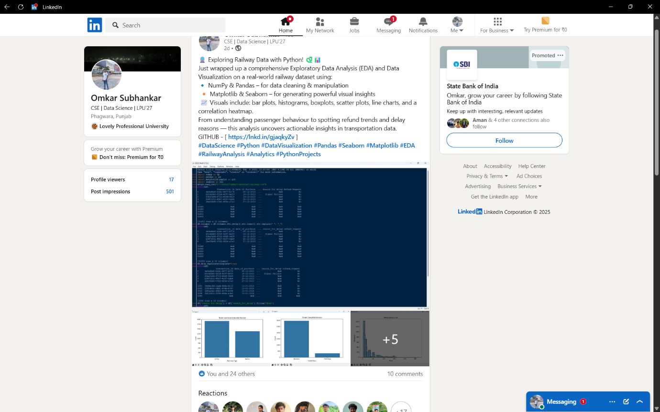

**Github:**

Link: [ <https://github.com/Omkar2629/Data-Visualization> ]

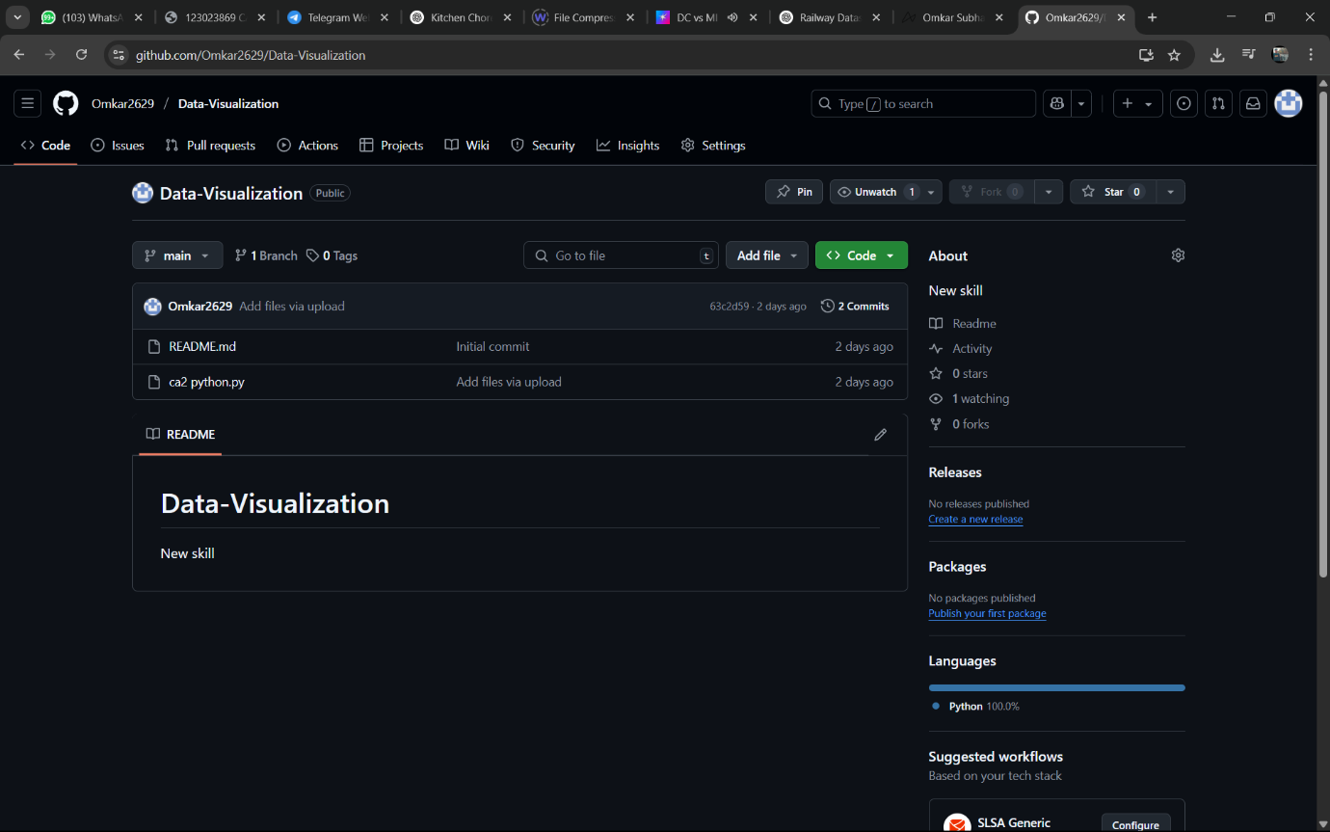

**Conclusion**

This exploratory data analysis of the railway ticket transaction dataset provides a comprehensive understanding of customer behaviour, pricing strategies, and operational performance in terms of delays and refunds. The following key conclusions were drawn from the analysis:

1. **Ticket Preferences**  
   Economy class and online purchases dominate, indicating price sensitivity and growing digital adoption.
2. **Price Patterns**  
   Prices vary significantly by ticket class and type, with premium and refundable options costing more.
3. **Refunds**  
   Refund requests are rare, suggesting overall customer satisfaction or strict refund policies.
4. **Delays**  
   Most journeys had no recorded delays; when delays occurred, they were mostly due to weather or system issues.
5. **Time-Based Insights**  
   Price trends fluctuate over time, hinting at seasonal demand or dynamic pricing strategies.
6. **Correlations**  
   Only weak correlations found between most variables, indicating complex passenger behaviour patterns.